**CP Club 365Days Challenge**

**Date – 21/11/2022**

**Programming language – c++**

**Problem Statement**

<https://practice.geeksforgeeks.org/problems/second-largest3735/1?utm_source=gfg&utm_medium=article&utm_campaign=bottom_sticky_on_article>

**Your Code**:

// 0x35Day of 0x365Days challenge

// VEDANT BHARAD

// 21-11-2022

//{ Driver Code Starts

#include <bits/stdc++.h>

using namespace std;

// } Driver Code Ends

//User function template for C++

class Solution{

public:

    int print2largest(int arr[], int n)

    {

        sort(arr, arr + n);

        for (int loop = n - 2; loop >= 0; loop--) {

            if (arr[loop] != arr[n - 1]) {

                return arr[loop];

            }

        }

        return -1;

    }

};

//{ Driver Code Starts.

int main() {

    int t;

    cin >> t;

    while (t--) {

        int n;

        cin >> n;

        int arr[n];

        for (int i = 0; i < n; i++) {

            cin >> arr[i];

        }

        Solution ob;

        auto ans = ob.print2largest(arr, n);

        cout << ans << "\n";

    }

    return 0;

}

// } Driver Code Ends

**Output (Screen Shot)**:

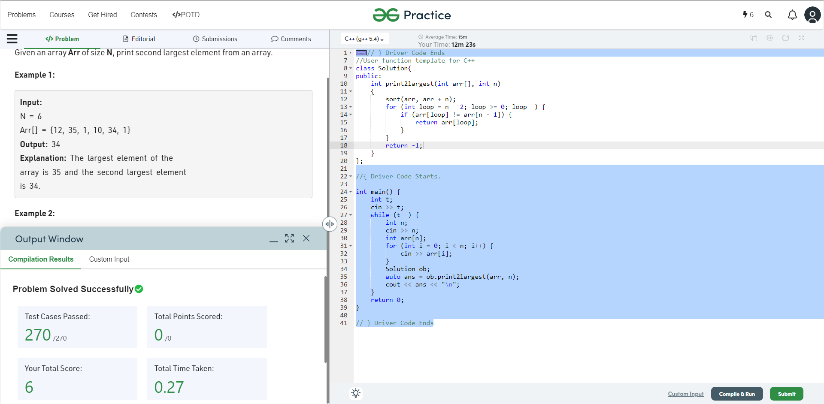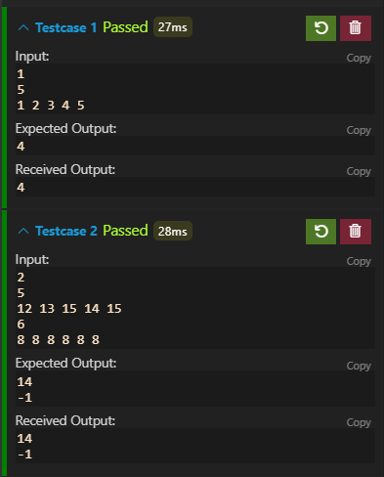

**Understanding about problem:**

* In this task there will be int array and I need to return second largest number if there is no any second largest number then return -1.

Note: If you can't understand the problem, feel free to contact us and we'll help you. Please don't copy and paste from anywhere.

ALL THE BEST

Team CP Club